# ****Simulation assignment****

# Tasks T1(3, 0.5), T2(4, 1.5, 3), T3(7, 1.0, 5) and A sporadic job arrives at t=50 having the execution time of 10 and a relative deadline of 30 using EDF scheduler

## What is the minimum/maximum/average response time of all tasks?

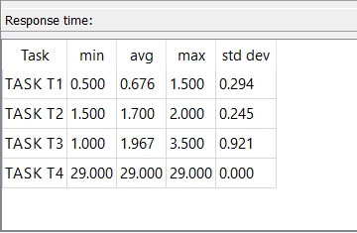

## Is any task missing the deadline? Which task? Where?

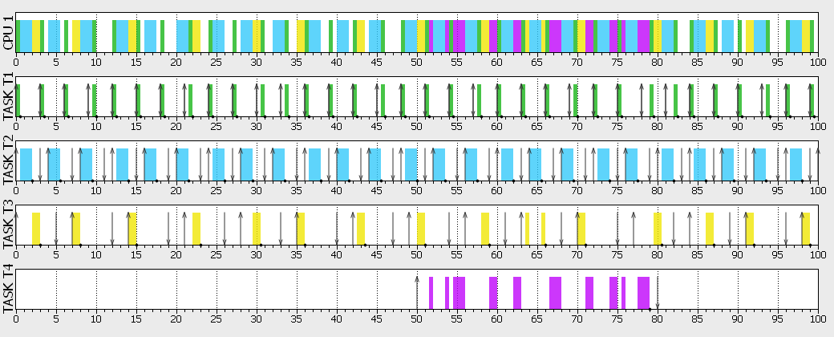

No tasks has missed deadline

## Is the sporadic job meeting its deadline?

No

## What is the response time for the sporadic job?

Task S1 activated at t=50 ended at t=79 , Then response time = 29.0 ms

# Tasks T1(3, 0.5), T2(4, 1.5, 3), T3(7, 1.0, 5) and A sporadic job arrives at t=50 having the execution time of 10 and a relative deadline of 30 using RM scheduler

1. **What is the minimum/maximum/average response time of all tasks?**

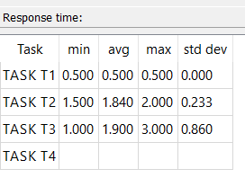

1. **Is any task missing the deadline? Which task? Where?**

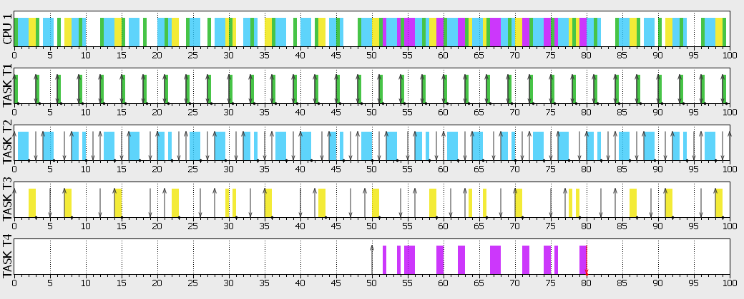 Yes task T4 (The sporadic Task) missed the deadline at t=80

1. **Is the sporadic job meeting its deadline?**

NO

## What is the response time for the sporadic job?

Task S1 activated at t=50 till t=80 , Then response time = 30.0ms but was not finished as it only worked for 9.5ms and it needed 10ms to finish

## Which scheduler is better is better in this example; EDF or RM?

EDF Scheduler is better because all tasks has met their deadlines

# ****Programming assignment****

## Questions

* Is the system fast enough to handle all aperiodic tasks? Why?

No , because the task “Matrixtask” is consuming the processor’s resources.

* If not, solve this problem without alter the functionality of any task ?

We may increase the priority of the Aperiodic task

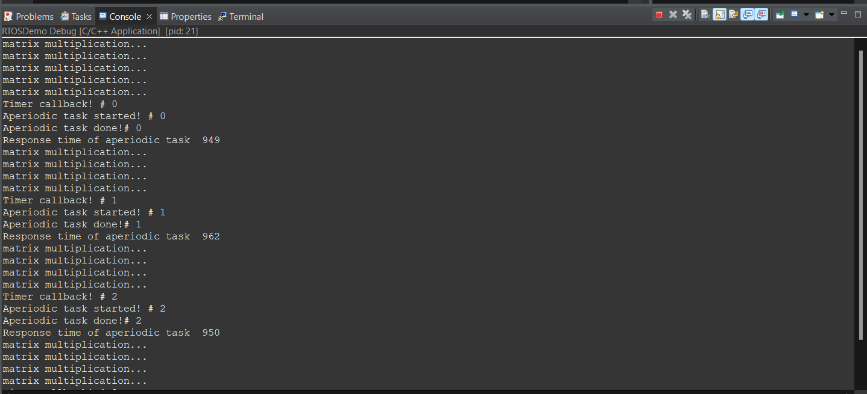screenshot below shows that response time is about 950ms after increased priority.

* What is the response time of the aperiodic task?

The response time changes depending on the state of the “Matrixtask” at this point

So it varied like shown in screenshots below from 3.723s to 12.552s

## ScreenShots

